1. Graphical user interface, text, application

   Description automatically generated
   1. Docker screenshot with Cassandra docker running
2. 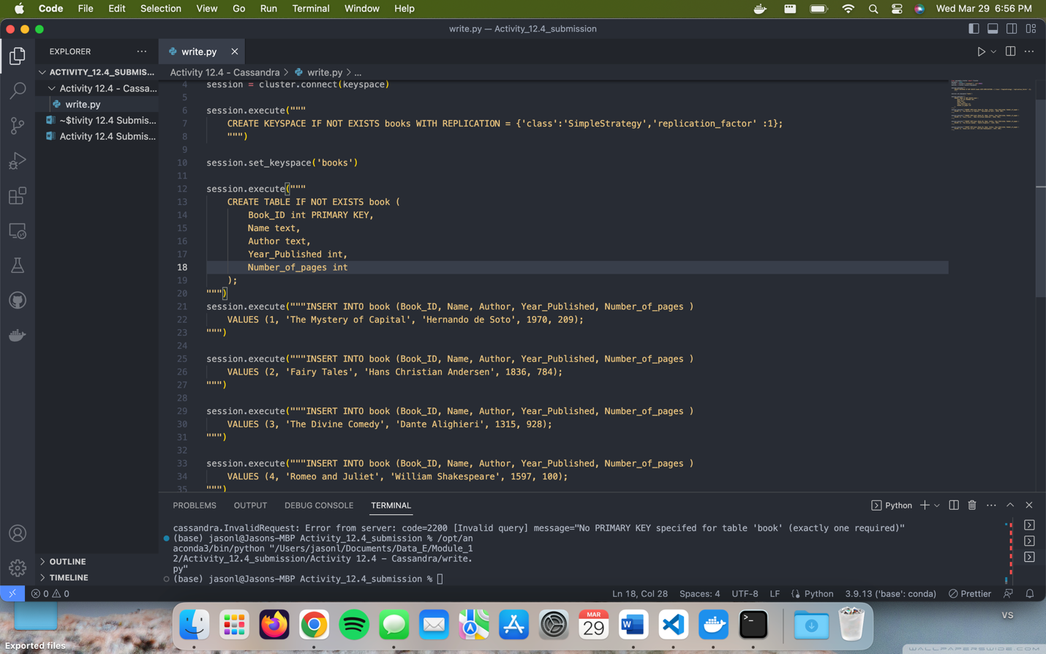
   1. Screenshot of code written and it successfully complete.
3. A screenshot of a computer

   Description automatically generated
   1. Code showing read functions and readout of 4 books
4. Table

   Description automatically generated with low confidence
   1. Screenshot showing both the correctly run insert statement to insert the 5th book and the select command showing them all.